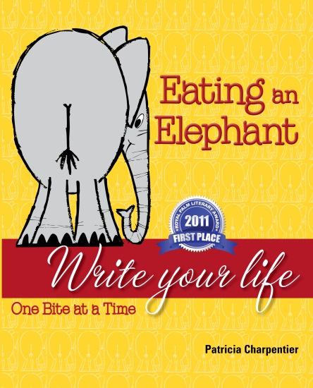
Based on the author’s twelve years of teaching, writing and editing personal and family history, Eating an Elephant: Write Your Life One Bite at a Time by Patricia Charpentier helps the reader break down the elephant-sized task of putting a life on paper into quick, easy-to-understand bites. As our society abandons letter writing in favor of temporal email, Facebook posts and tweets, we lose a means of preserving personal and family history.

Eating an Elephant, first place winner of a Royal Palm Literary Award in 2011, encourages both experienced storytellers and those who do not think they can write to put their life experiences on paper for themselves, their families and the generations yet to come. The book is steeped in the author’s rich heritage and offers readers an opportunity to learn a little Cajun French and catch a glimpse into South Louisiana culture.

Eating an Elephant shows the reader how to get started, write descriptively, bring people to life, recreate conversations, compose strong sentences and edit and revise in two hundred short, palatable bites. The final section of the book takes a look at grammar and punctuation and can be used as a reference throughout the writing process.

Written with humor and the author’s unique approach to writing, readers can sample bites such as “Follow Your Nose,” “Make a Scene,” “And the Title Goes To,” “Slay the Dragon,” “Start Anywhere,” “Capitalize That” and “English Can Be Challenging,” just for starters. In addition, the author pauses throughout the book and provides exercises, which allow readers to practice new lessons learned.

Patricia Charpentier holds an M.A. in creative writing from the University of Central Florida and a B.A. in journalism from Louisiana State University and has worked as a memoirist, writing coach, editor, writing instructor, journalist and photographer. She also had a twenty-eight-year career in mortgage banking information technology. Originally from South Louisiana, Patricia now lives in Orlando, Florida with her husband Bob.

For more information on Eating an Elephant, contact the author.
Email – writingyourlife@cfl.rr.com
Phone – 321.279.1791
Website – www.writingyourlife.org

Eating an Elephant: Write Your Life One Bite at a Time by Patricia Charpentier
Published in 2011 by LifeStory Publishing
171 pages, $16.95 for paperback, $9.99 Kindle version
ISBN-13 #978-0-9832382-3-2
ISBN-10 #0-9832382-3-5

